TWEED RIVER HIGH SCHOOL
Innovation, Opportunity and Success

ATP Information
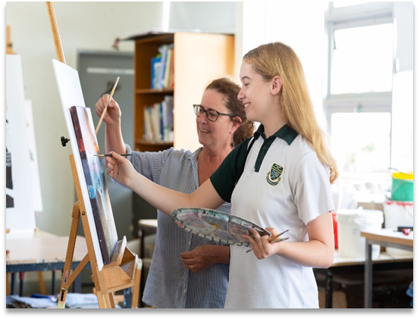
Our Academic Talent Pathway program is designed to enhance the learning outcomes of academically advanced students. The program has been running for over 10 years and TRHS prides itself on being the only school in the area to run an academic class for all four years of junior high school.

Why?
The NSW Department of Education has a commitment to targeting the top 25% of students. Our program provides different learning opportunities – it is not just about streaming talented students into the one class. We focus on the way we teach students and students develop an awareness of how they best learn.

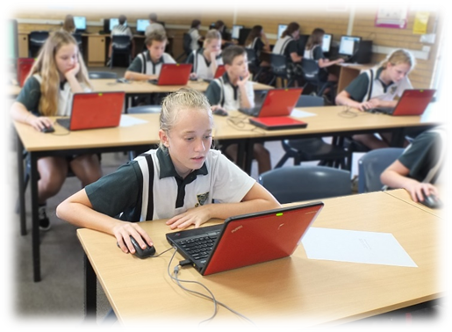
Our aims

Teachers
- Coordinate our Stage 4 & 5 programs
- Explicitly teach and scaffold skills
- Build Higher Order Thinking content
- Extend students beyond syllabus outcomes
- Research and develop learning based on the application of current research
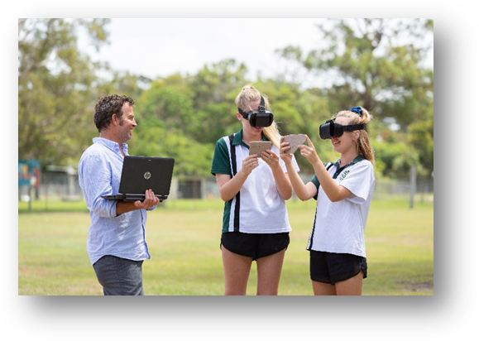

Students
- Maintain high levels of commitment to their studies
- Strive for continuous improvement (PBs)
- Apply themselves across all their classes

Our Reputation – Where are they now? (a very small selection!)
2016 ATP
Jessica: Scholarship for Law at Bond – completed degree
Sam: Engineering Cadetship with Tweed Shire Council
Megan: Graduated Law at Bond and is training as a helicopter pilot
2017 ATP
Tarryn: Studying Bachelor of Psychology, on the Broncos and Australian touch football teams
Gemma: Bachelor of Architecture at Bond University
2018 ATP
Sophie: Studying Criminology at QUT
Bronte: Studying Bachelor of Biomedical Science at UQ
Billy: Studying Bachelor of Psychology at Griffith Uni

ATP Enrichment Activities

There are a wide range of extra activities offered to ATP students. Students who are accepted into the program are expected to participate in the extra enrichment activities.

- Year 9&10 Melbourne excursion
- Year 7&8 University Taster Days
- Year 7 Brisbane Museum
- Year 9&10 WWI interactive presentation
- Other subject specific and learning enrichment activities that may become available

What do the students say?

- I very much enjoy the ATP and am excited to continue in this class
- Maths is fun, it can be challenging and I learn a lot every day – we go quickly through the things we already know and then get onto harder work
- I’ve enjoyed the assessment tasks – we’re allowed to be creative
- Science is good because we do real experiments
- The peer support in my class is really good – everyone is really nice to me
- ATP is a great class, I learned heaps of new things & made new friends
- It’s our last year together – can we have a Year 11 ATP roll call?

Selection Process for Year 7 students

- Entrance Exam in September 12th 2022 – 4pm (complete application form)
- An interview with ATP coordinators, executive members and teachers –Term 4 Week 4&5
- Notification of acceptance by mail - late November

