Academic Talent Pathway
Tweed River High School

Enhancing the Learning Outcomes for Academically Advanced Students

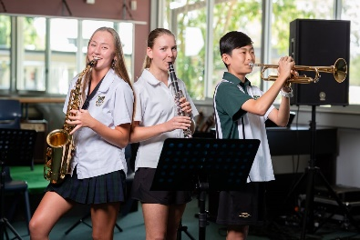

ATP – EXPRESSION OF INTEREST

Dear Mr Lambert,

I would like to be considered for inclusion in the ATP class in Year

Name: ………………………………………………………

Current English and Maths classes: ……………………................ ……………………................

In order to be included in this program I will:

Have a positive attitude, be learning focused and motivated to extend myself to achieve the best possible outcomes by:

- Cooperating and respecting the learning of others
- Attempting to do my best at all times, showing exemplary behaviour and observing all rules and instructions
- Completing all assessment work, including extension work, classwork, assignments and practical activities
- Participating in extra ATP activities such as subject competitions, excursions and fieldwork.

As a member of the ATP, you will be allocated a position in a specific ATP English class in Stage 4 (Yrs 7 & 8). In Stage 5 (Yrs 9 & 10), you will be allocated a position in either English 1 or English 2, depending on your prior performance in this subject area.

I am aware that there is a yearly fee of $100 for the ATP program. I am aware of, and agree to meet, all of the requirements for the ATP class. I am aware that, if I do not meet these conditions, I may be withdrawn from the program. I understand that the success of this application will be based on the results I have achieved so far at Tweed River High School and teacher recommendations.

Signed: …………………………………… (Student)

Signed: …………………………………… (Parent/Caregiver) Date: …………………………

In the space below, applicants (the student) are required to write a response explaining why they wish to be part of the ATP and why they will succeed in this program.

………………………………………………………………………………………………………………….

………………………………………………………………………………………………………………….

………………………………………………………………………………………………………………….

………………………………………………………………………………………………………………….

………………………………………………………………………………………………………………….

………………………………………………………………………………………………………………….

………………………………………………………………………………………………………………….

………………………………………………………………………………………………………………….

………………………………………………………………………………………………………………….

………………………………………………………………………………………………………………….

………………………………………………………………………………………………………………….

………………………………………………………………………………………………………………….

………………………………………………………………………………………………………………….

………………………………………………………………………………………………………………….

………………………………………………………………………………………………………………….

………………………………………………………………………………………………………………….

………………………………………………………………………………………………………………….

………………………………………………………………………………………………………………….

………………………………………………………………………………………………………………….

………………………………………………………………………………………………………………….

………………………………………………………………………………………………………………….

………………………………………………………………………………………………………………….

………………………………………………………………………………………………………………….

………………………………………………………………………………………………………………….

………………………………………………………………………………………………………………….

